Notatki pod kątem artykułu wnioski cytaty itd.
On average, socio-economically advantaged students reported higher social and emotional skills than their socio-economically disadvantaged peers in all cities participating in the survey.

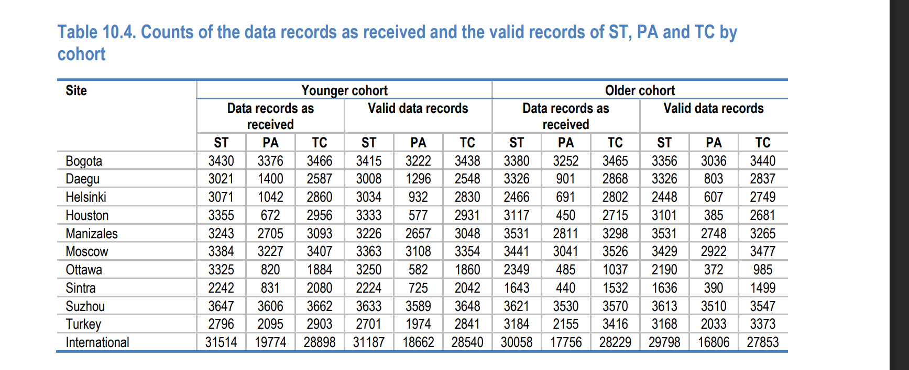

Ciekawe klastry Stanbuł (8), Sintra(10), Suzhou (11)

